**TheBlackHoods 6 – TBH6 (Musician/Band)**

**Feasibility Report**

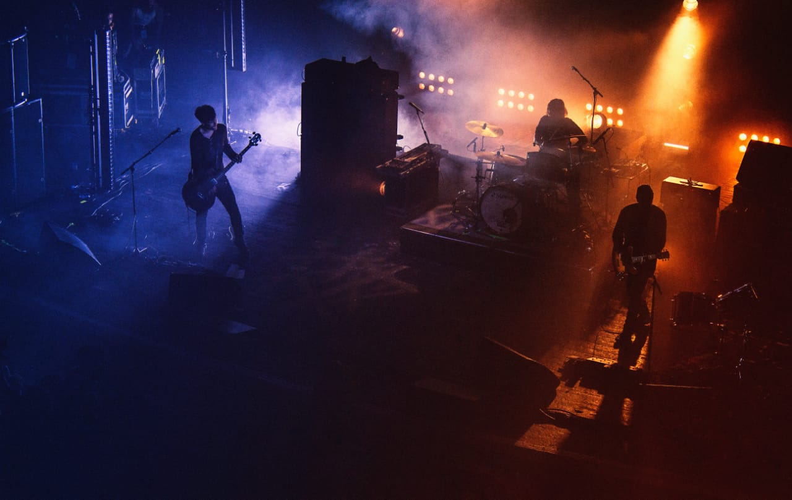

**TABLE OF CONTENTS**

1. **The Client** ………………………………………… **3**
2. **Team Members**…………………………………… **3**
3. **Statement of the task to be undertaken**….…….... **4**
4. **Preliminary Requirement Analysis**………....…… **4**
5. Functional Requirements…………….… **5**
6. Non-functional Requirements…………. **5**
7. **Suggested Deliverables**…………………………… **6**
8. **Process to Be Followed**…………………………… **7**
9. Iterative Refinement Process………...… **7**
10. **Outline Plan** ………………………………………. **8**
11. Activities & Milestones ……………….. **8**
12. **Visibility Plan** …………………………………..… **9**
13. Gantt chart………………………...…… **9**
14. **Business Considerations**……………………….… **10**
15. **Risk Analysis**……………………………………... **11**
16. **Technical Requirements**…………………………. **12**
17. **The Client:**

The BlackHoods 6-TBH6 is a newly formed band consisting of youngsters who are very passionate about music. They are an exceptional band with members having different skills such as Guitarists, Leads, Bassist, Vocalist, Darbooka player, and so. The issue which is currently being faced by them is that they are struggling from communication gap between them and their fans. They don’t have any proper website and they are not getting proper reach through different social media platforms. So, they have decided to become more professional and start a website where their fans can search for their upcoming events, albums, singles, announcements, etc. Where the fans can also learn about the struggles and hard work of their favorite band members and their accomplishments.

1. **Team Members:**
2. Muhammad Khizer Atiq (41374)

[khizeratiq1@gmail.com](mailto:khizeratiq1@gmail.com)

1. Muhammad Nauman Saleem (41307)

[noumansaleem1999@gmail.com](mailto:noumansaleem1999@gmail.com)

1. Zaid Bin Hameed (41086)

[zaidhameed170606@gmail.com](mailto:zaidhameed170606@gmail.com)

1. Javeria Salim (42300)

[javeriasalim4@gmail.com](mailto:javeriasalim4@gmail.com)

1. Muhammad Ahmed (41396)

[ahmed.khatri.908@gmail.com](mailto:ahmed.khatri.908@gmail.com)

1. **Functional Requirements:**

The system will meet the following functional requirements:

**Administration Side:**

* A user-friendly web interface which allows the administrator to update, edit or delete the content.
* A responsive user interface would be provided. A person who would be visiting the app from mobile would see the same features and interface.
* Display of necessary information and details of the band members.
* Can upload data like music videos, or any content which a user wants to share.
* Can upload or announce the details about the performances or jammings that public can join.
* Can change or add the roles of the band members in the about us page.

**Public Side:**

* Must be able to watch the videos online and
* Can visit to the band page on other platforms by clicking on the links.
* Must be able to do advance booking of the band to perform for them.
* Can contact the managing director by visiting the contact us page.
* Can be notified about the announcements of the gatherings or performances of the music band.
* Must be able to give their feedback to the particular band member as well as collectively about their performances.
* Must be able to see the feedbacks and recommendations of others.

1. **Non-Functional Requirements:**

The interface of the website will be responsive. The criteria of the success of the website will be measured by the number of visitors on the website and the feedback provided by them. The functionality and ability of the website to meet all requirements (i.e. Simple and user friendly UI, the information page of the band members and their contact links, a page for the music content with specific user controls, responsive website, etc.) would be critical for success as well. Ease of use and efficiency would be adequate measures of performance; after a week of developing and testing the website, the users should be able to use the website effectively.

1. **Suggested Deliverables:**
2. **Timely Updates:** Documentation and the presentation of the project would be provided timely to the client, just to make sure that the group is working on the system with matches closely to the client’s requirements. This would give a chance to the client if he wants to make any modifications, or correct items that were not correctly understand, or miscommunicated or by the team before allowing them to move forward to the next step.
3. **Design Document:** A document and a presentation would be provided. This will help the client to understand that how the project is to be implemented. This will be done by the ones who are more experienced with hands-on knowledge about the documentation and technical work just to ensure that the client would be satisfied by the ongoing work.
4. **Timely Meetings:** As per the client requirements, they want timely meetings with the team in order to provide feedback about the ongoing work and to see to progress of the project, one or two meetings will be held where the group will also provide them a general overview about the outcome and the scope of the project.
5. **Source Code:** Source code is the final deliverable which would be provided with the documentation and the presentation. This will tell the project is done and concluded. In this final deliverable the team would be showing that how to implement the project according to the requirements the client mentioned. This project would be tested before the final presentation and then it will be given to the client when it will be ready to be run.
6. **User Guide:** User guide documentation would be provided to the client which will explain them how to use the project and how to make changes as they mentioned in the requirements.
7. **Demonstration and Information:** As per need of the client we will show them how to run this website and give them a demo that how to operate the website. We’ll give the technical staff the required training if it is needed.
8. **Feedback:** After a short while, the client will provide his feedback about the website, and just for the cause of good relations with the client, if any change is needed we will work on it just to make the client satisfy so that in future the client would consider us for their more upcoming projects.

**Survey Questions From Muhammad Nauman Saleem (41307)**:

1. Are you satisfied with the functional and non-functional requirements of the project?
2. Do you think this project will help you in the growth of your band?
3. Are you satisfied with the documentation and the presentation of the group?
4. Do you think that timely updates about the project help the team to implement according to the client’s need?
5. Do you agree with the fact that the team worked according to your requirements and interests?